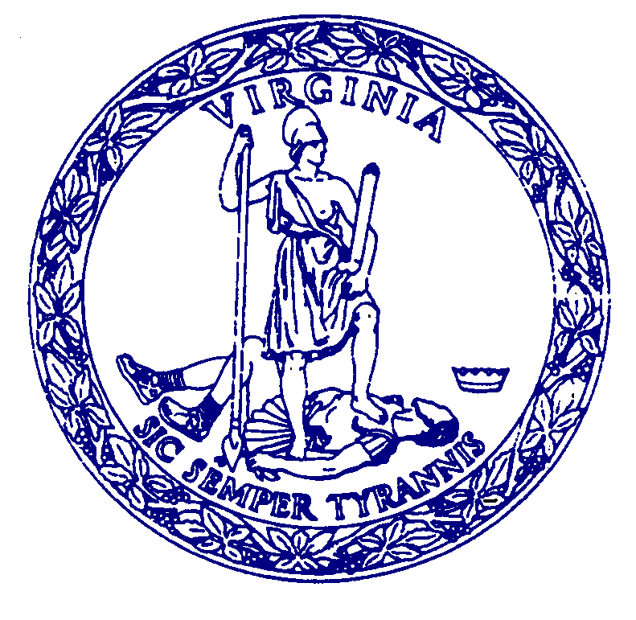
AGENDA

MEETING

of the

COMMISSION FOR HISTORICAL STATUES IN THE UNITED STATES CAPITOL

1:30 p.m.
Wednesday, June 18, 2025

Virginia Museum of History & Culture
Reynolds Leadership Center – 2nd Floor
428 N. Arthur Ashe Boulevard, Richmond

Call to Order………………………………………………..……Senator Louise Lucas, Chair

Roll Call Attendance……………..……………….………………….……Stephanie Williams

Approval of Meeting Agenda

Approval of February 24, 2024 Meeting Minutes

Approval of Virtual Meeting Policy……………………………………...Stephanie Williams

Public Comment…………………………………………………….……..Stephanie Williams

Presentation of Completed Statue………………….………….…………..…..…Julie Langan

Next Steps……………….………………………………………..………………...Julie Langan

Adjourn

