COMMONWEALTH OF VIRGINIA

Department of Historic Resources
2801 Kensington Avenue, Richmond, Virginia 23221

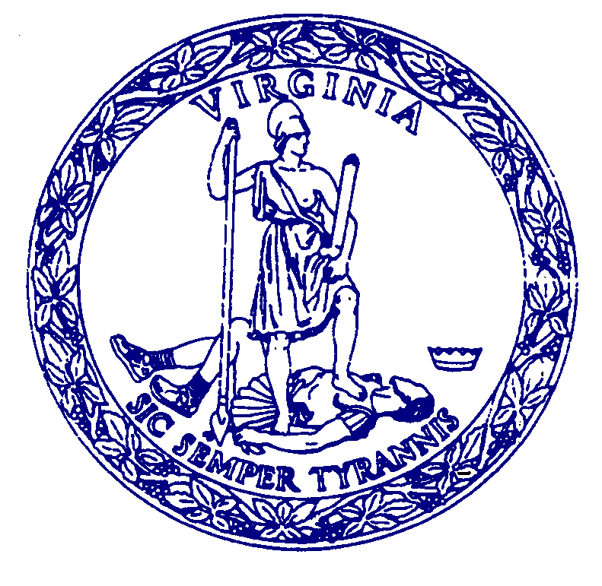
DRAFT AGENDA

JOINT MEETING
STATE REVIEW BOARD and BOARD OF HISTORIC RESOURCES
10:00 a.m. September 18, 2025
Reynolds Leadership Center, Virginia Museum of History and Culture, 428 N Arthur Ashe Boulevard, Richmond, VA 23220

Call to Order John Mullen, Chair, State Review Board
Roll Call to establish presence of quorum
Reading of Land Acknowledgment Statement
Introduction by Chair and explanation of SRB’s purpose
Notice of hybrid meeting format and recording
Approval of the Meeting Agenda
Vote on June 12, 2025, meeting minutes
Vote on 2026 meeting schedule

Call to Order Aimee Jorjani, Chair, Board of Historic Resources
Roll Call to establish presence of quorum
Election of Chair and Vice-chair
Introduction by Chair and explanation of BHR’s purpose
Notice of hybrid meeting format and recording
Approval of the Meeting Agenda
Vote on June 12, 2025, meeting minutes
Vote on 2026 meeting schedule

Director’s Report presented by Julie Langan

BIPOC Update presented by Caitlin Sylvester

Public Comment

Five Minute Break

NOMINATIONS

Statewide presented by Austin Walker
- African American Churches in Virginia Multiple Property Documentation Form, DHR File No. 500-0010 Δ >

Eastern Region presented by Joanna McKnight and Ari Calos
- Bright Hope Baptist Church and Cemetery, Louisa County, DHR File No. 054-5480 Δ $
- Woodland Cemetery, Henrico County and City of Richmond, DHR File No. 043-0742 Δ ∗∗
- Bear Garden, King William County, DHR File No. 050-0005 **
- Rocky Branch School, Dinwiddie County, DHR File No. 026-5114 Δ $
- Daily Press Building, City of Newport News, DHR File No. 121-5563
- Norfolk Cultural and Convention Center, City of Norfolk, DHR File No. 122-5968 **

Northern Region presented by Aubrey Von Lindern
- William H. Randall Estates, Fairfax County, DHR File No. 029-6392 Δ ***
- Wine House, Shenandoah County, DHR File No. 085-0178

Western Region presented by Mike Pulice
- Parry McCluer High School, City of Buena Vista, DHR File No. 103-5194
- P. Lorillard Tobacco Company Warehouse Complex, City of Danville, DHR File No. 108-6186 **
- Abingdon Historic District 2025 Update, Town of Abingdon, Washington County, DHR File No. 140-0037 * **

Break: Joint Session Ends

BOARD of HISTORIC RESOURCES
Virginia Museum of History and Culture, 428 N Arthur Ashe Boulevard, Richmond, VA 23220
Starts approximately 45 minutes after adjournment of Joint Meeting

Call to Order Aimee Jorjani, Chair, Board of Historic Resources
Roll Call to establish presence of quorum
Land Acknowledgement Statement
Introduction by Chair and explanation of BHR’s purpose
Notice of hybrid meeting format and recording

Introduction by Chair

Highway Marker and Easements Public Comment

HIGHWAY MARKERS presented by Jennifer Loux

New Markers

1.) Cypress Chapel Christian Church

Sponsor: Cypress Chapel Christian Church
Locality: City of Suffolk
Proposed Location: 1891 Cypress Chapel Road

2.) Danville Canal

Sponsor: The Danville Research Center for African American History and Culture
Locality: City of Danville
Proposed Location: 424 Memorial Drive

3.) Antioch (Rosenwald) School

Sponsor: Antioch Baptist Church
Locality: Mathews County
Proposed Location: 183 Antioch Road, Susan, VA

4.) Dr. Elbyrne Grady Gill (1891-1966)

Sponsor: Nelson Harris
Locality: City of Roanoke
Proposed Location: 700 block of South Jefferson Street

5.) Blue Ridge Parkway

Sponsor: American Society of Civil Engineers, Virginia Section
Locality: Nelson County
Proposed Location: Rockfish Gap Scenic Overlook, I-64 East

6.) Gilbert’s Restaurant

Sponsor: Pittsylvania Historical Society
Locality: Pittsylvania County
Proposed Location: 401 N. Main Street, Chatham

7.) Patrick Central School

Sponsor: Patrick Central School Alumni
Locality: Patrick County
Proposed Location: Salem Highway (Route 8) near intersection with Black Jack Road

8.) TransAmerica Bicycle Trail

Sponsor: Jennifer and William C. Lee
Locality: Botetourt County
Proposed Location: Catawba Road west of US 220

Replacement Markers

1.) Gen. Edward Stevens (ca. 1745-1820) G-10
Sponsor: DHR
Locality: Town of Culpeper
Proposed Location: N. Main Street at intersection with Carpenter Drive

2.) Pisgah United Methodist Church X-25
Sponsor: VDOT
Locality: Tazewell County
Proposed Location: US 460/19 (Trail of the Lonesome Pine) at intersection with Orchard Road

3.) Gabriel’s Uprising SA-66

Sponsor: DHR
Locality: City of Richmond
Proposed Location: Broad Street between I-95 and N. 16th Street

4.) Medical Department of Randolph-Macon College F-69

Sponsor: VDOT
Locality: Prince Edward County
Proposed Location: US Route 15, south of intersection with Route 758

5.) Action at Mill Creek A-71
Sponsor: VDOT
Locality: Shenandoah County
Proposed Location: Senedo Road (Route 42) near intersection with Orkney Grade Road (Route 263)

Applications Under Consideration for December Board Cycle

1.) Thomas Laws (Clarke County)
2.) James A. Bland High School (Town of Big Stone Gap)
3.) Hippodrome Theatre and the T.O.B.A. Circuit (City of Danville)
4.) Battle of Wyerman’s Mill (Lee County)
5.) Maymont (City of Richmond)
6.) Gen. Anthony Wayne’s Rappahannock Crossing (Fauquier County)
7.) Cypress Baptist Church (Surry County)
8.) Home of Future U.S. President Jimmy Carter (City of Norfolk)
9.) Northside High School (Pittsylvania County)
10.) Clarence Smith (City of Danville)
11.) Goochland Recreational Center, Inc. (Goochland County)
12.) Crossing the Watershed Divide (Roanoke County)
13.) Sir John Peyton (Mathews County)
14.) Pohick Indians (Fairfax County)
15.) Mojo Nixon (City of Danville)
16.) French Quarter Cafe (City of Alexandria)

Interpretive Sign for Brown Grove Rural Historic District, Hanover County

Lafayette’s Tour Marker, James City County

New Kent County Local Marker Program

EASEMENTS

Easement Offers for Consideration presented by Kyle Edwards

1. Nason Tract, Second Manassas Battlefield, Prince William County
Easement Applicant: American Battlefield Trust
Offer for ±2.7116 acres
Grant Funding: American Battlefield Protection Program, Virginia Battlefield Preservation Fund

2. Marshall Tract, Rappahannock Station Battlefield, Fauquier County
Easement Applicant: American Battlefield Trust
Offer for ±0.849 acres
Grant Funding: American Battlefield Protection Program, Fauquier County

3. Goodale II Tract, Deep Bottom II Battlefield, Henrico County
Easement Applicant: Richmond Battlefields Association
Offer for ±5.708 acres
Grant Funding: Virginia Battlefield Preservation Fund

Easements Recorded since the June 12, 2025 Meeting presented by Kyle Edwards

1. Wiseman Tract, Cedar Mountain Battlefield, Culpeper County
Easement Donor: Virginia Outdoors Foundation
Acreage: ±155.7199
Recorded: July 9, 2025
Deed of Assignment of Open-Space Easement

2. Buckland Church, Buckland Mills Battlefield, Prince William County
Easement Donor: Thomas J. Ashe, III and Timothy M. Purnell, Trustees of the Thomas J. Ashe, III Exempt Trust Arising
under the Thomas J. Ashe, Jr. Trust dated January 3, 1997
Acreage: ±0.93225
Recorded: August 29, 2025

3. Mauller Tract, Second Manassas Battlefield, Prince William County
Easement Donor: American Battlefield Trust
Acreage: ±3.1121
Recorded: August 29, 2025

Adjourn – Board of Historic Resources

STATE REVIEW BOARD
Collections Room, Virginia Department of Historic Resources, 2801 Kensington Avenue, Richmond, VA 23221
Starts approximately 45 minutes after adjournment of Joint Meeting

Preliminary Information Forms
(Public comment will be invited during discussion of each region’s PIFs; comments must be limited to 5 minutes per property. Please note that agenda order is subject to change.)

Consent Agenda:
Eastern Region
- Webb House, Greensville County, DHR File No. 040-0001
- Broad Creek Shores Historic District, City of Norfolk, DHR File No. 122-6495 Δ **
- Boswell Mansion, Town of Chase City, Mecklenburg County, DHR File No. 186-5173
- The Virginia Home, City of Richmond, DHR File No. 127-6157 **
- Hamilton Road Bridge, Louisa County, DHR File No. 054-5010

Northern Region
- Saunders House, Town of Warrenton, Fauquier County, DHR File No. 156-5200 **
- David Clayton House, Frederick County, DHR File No. 034-1092

Western Region
- Montvale High School, Bedford County, DHR File No. 009-0306
- South Boston Historic District Boundary Increase, Town of South Boston, Halifax County, DHR File No. 130-5025

Discussion Agenda:
Eastern Region presented by Joanna McKnight & Ari Calos
- King’s Pond Mill, Hanover County, DHR File No. 042-0091 **
- Goochland Recreation Center, Goochland County, DHR File No. 037-5246 Δ

Northern Region presented by Aubrey Von Lindern
- Red Brick House, City of Waynesboro, DHR File No. 136-5092
- Oakland Baptist Church, City of Alexandria, DHR File No. 100-0211 Δ **
- Thoroughfare Historic District, Prince William County, DHR File No. 076-5150 Δ **

Western Region presented by Mike Pulice
- Calvary Rural Historic District, Halifax County, DHR File No. 041-5926
- Victoria Furnace, Rockbridge County, DHR File No. 081-5810 Δ

Adjourn – State Review Board

* Cost Share Sponsored Project
** Certified Local Government
*** Certified Local Government Grant Sponsored Project
Δ Associated with African American History
# Associated with Virginia Indian History
^ ESHPF Grant-Funded Project
% State Stewardship
> National Park Service Grant-Funded Project
} Sponsored by Local Government (no grants utilized)
< Threatened Sites state grant
{ African American Outreach state grant
| National Trust for Historic Preservation private grant
\ BIPOC application
$ Associated with a Multiple Property Documentation Form

